For Immediate Release:

Flowers

Merrill Wagner at Sundaram Tagore Gallery

February 28th – April 7th, 2007
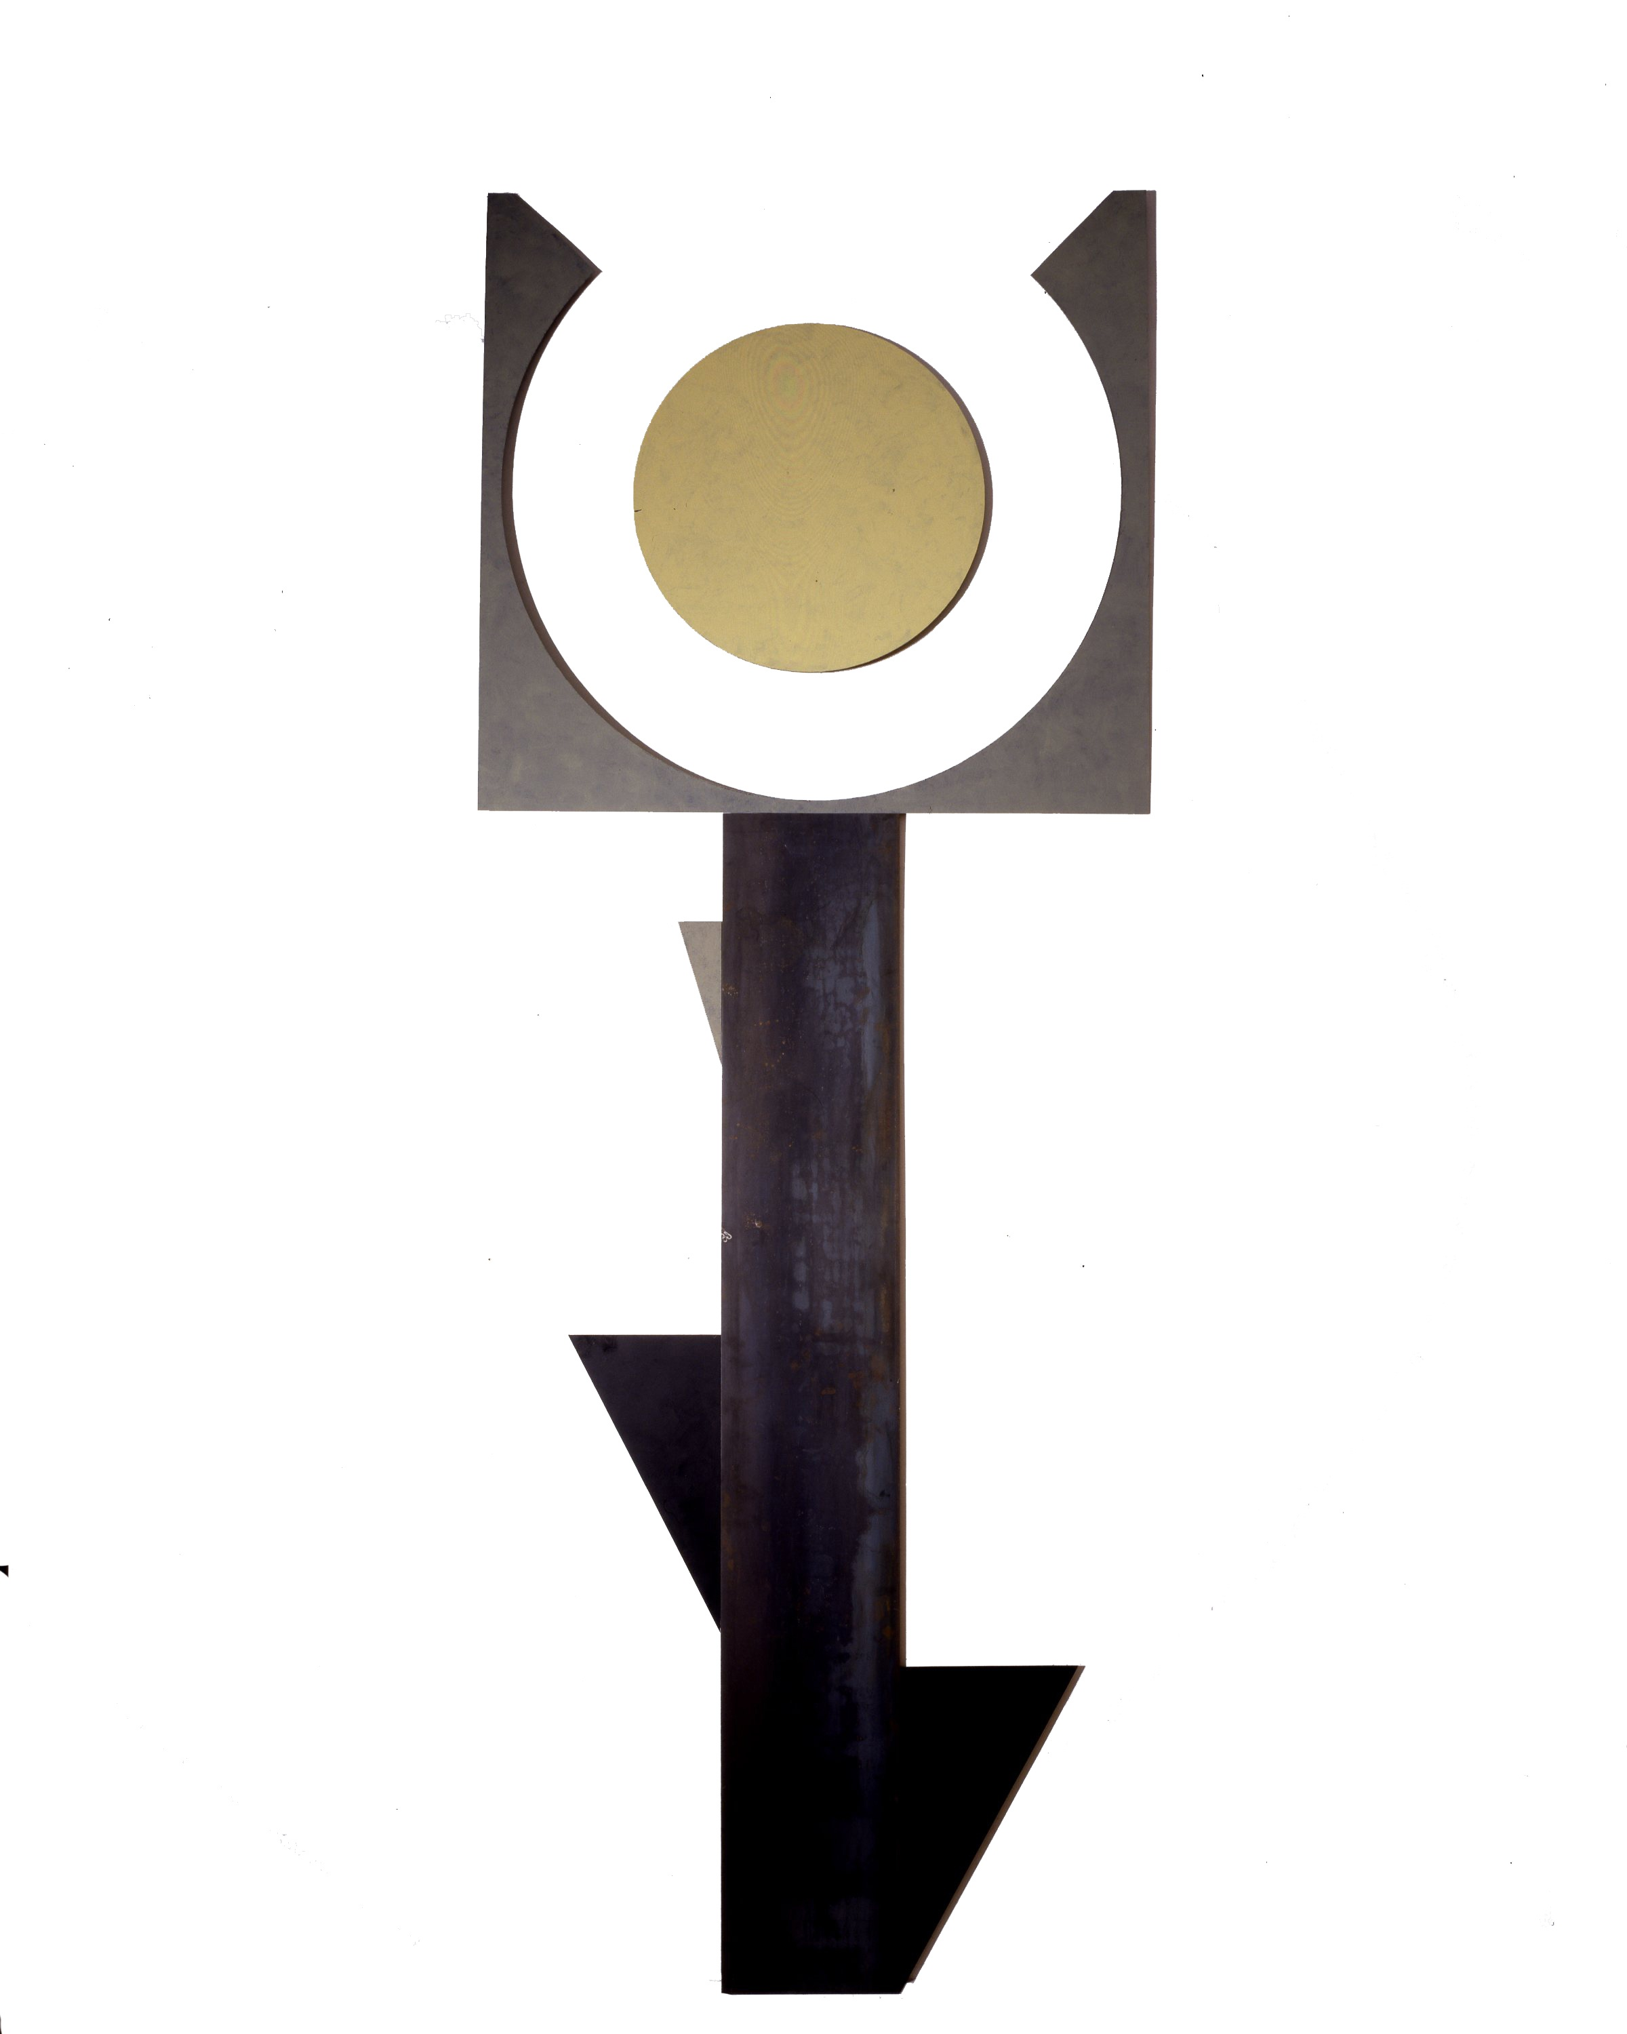
New York, NY, February 16, 2007—Sundaram Tagore Gallery is pleased to present Flowers, an exhibition of new paintings by Merrill Wagner. Merrill Wagner is a celebrated artist venerable for her dedication to conveying the romanticism of the ‘Great American Landscape.’ Her work is noted for her use of contrasting color, geometric abstraction, as well as the balance of man versus nature and sculpture versus painting. The exhibition begins February 28th and continues through April 7th. An opening reception will be held at the gallery February 28th from 6:30 to 8:30PM.

Wagner’s Flowers are a bold departure from her known geometric abstractions. The inherent beauty of materials and the shape of found objects continue to guide her process, but color intensity is more vivid and the predetermined shapes of materials now lend subject matter. The Flowers exhibition epitomizes the artist’s love for the natural world, her intrigue with its beauty, and concern for the environment. Employing the use of steel tempered with the human
Merrill Wagner, Desert Flower hand, Flowers reshapes space and juxtaposes man and nature, as
140 x 52”, Paint on steel, 2006 well as sculpture and painting in an exciting and monumental way.

Wagner was raised in the Pacific Northwest and moved to New York City in the late 1950s, after graduating from Sarah Lawrence College. Inspired by the minimalist Eva Hesse in the late 1960s, Wagner began to experiment with diverse media. By the 1980s she was painting on stone, steel, and slate, focusing on the unique nuances of surfaces. She has held teaching positions at Princeton University and Parsons School of Design. In 1989, Wagner received a National Endowment for the Arts Visual Artists Fellowship Grant. Her work has been included in over forty individual and group exhibitions in the United States and abroad. She has been a member of the American Abstract Artist since 1976 and served as its president from 1982 to 1985. A catalogue accompanying the exhibition, written by David Shapiro, is available at the gallery.

About Sundaram Tagore Gallery
Established in 2000, Sundaram Tagore Gallery is devoted to examining the confluence of Western and non-Western cultures. The focus is on developing exhibitions of intellectual rigor and showcasing artists who are engaged in spiritual, social and aesthetic dialogues with traditions other than their own.

Our interest in cross-cultural dialogue extends beyond the visual arts including many other disciplines, including poetry, literature, performance art, film and music. We host non-profit events that stimulate the exchange of ideas and push the envelope of artistic, intellectual and cultural boundaries. Our focus is to help artists of all ages, and art organizations from around the globe to exhibit, perform and produce their work.

